## Senzo Masango

## 4471

## Basic Programming 1A (BCP411)

## 

INDEX

1. Difference bewtween Python 1,2,3

There are many differences between the Python versions mentioned above all with disadvantages and advantages that leave them superior to the previous version, with the most popular versions being 2 and 3,however 2 is becoming obslete with version 3 taking over and known as the future

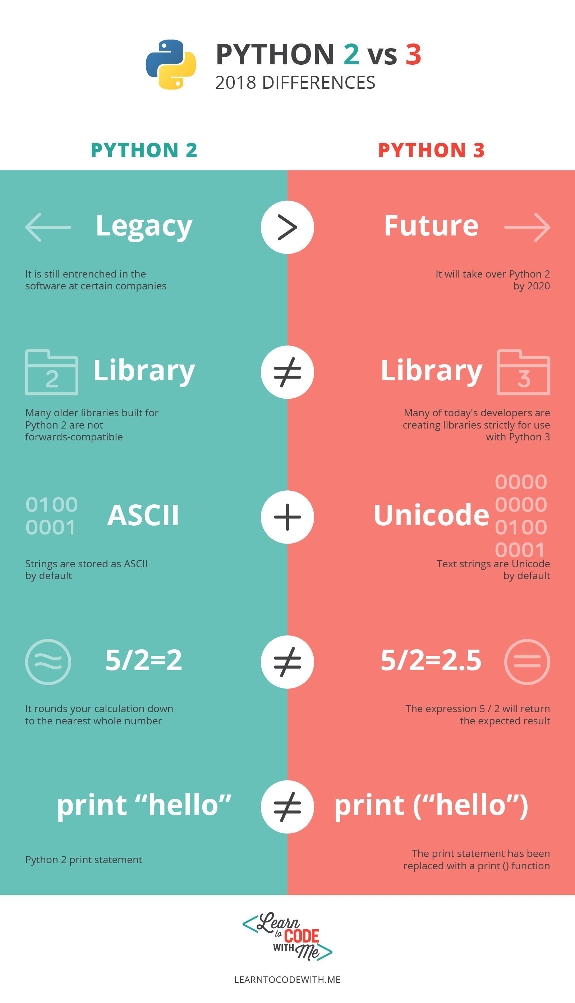As the image provided below by learntocode.me

It clearly highlights the main the diffrences

*There is better Unicode support in python 3

*there are different(incompatible) libraries

Since most libraries are for python 3 and are incompatible for 1,2

*2,3 have a better integer division

Therefore most companies today are migrating to python three and leaving 2,1 as three is the future and has many advantages